**MASTER TABLE:**

COMMANDS TO BE RUN BEFORE CREATING ORC TABLE:

#(must run these commands aftering entering into HIVE and after entering into database i,e use databse_name;)#

set hive.support.concurrency = true;

set hive.enforce.bucketing = true;

set hive.exec.dynamic.partition.mode = nonstrict;

set hive.txn.manager = org.apache.hadoop.hive.ql.lockmgr.DbTxnManager;

set hive.compactor.initiator.on = true;

CREATING ORC MASTER TABLE:

create table master(id int, name string, email string, mobile bigint, course string, fee int, discount int, status1 string, status2 string) clustered by (id) into 4 buckets stored as orc tblproperties('transactional'='true');

1. CREATING TEMPORARY TABLE:

create table temp (id int, name string, email string, mobile bigint, course string, fee int, discount int, status1 string, status2 string) row format delimited fields terminated by ',' lines terminated by '\n' stored as textfile;

1. LOAD DATA INTO TEMP TABLE:

load data local inpath '/home/cloudera/Desktop/demo_project/Master Table.txt' into table temp;

1. CHECK IF TEMP TABLE HAS DATA:

select * from temp;

1. TRANSFER FROM TEMP TO MASTER:

insert into table master select * from temp;

1. CHECK IF MASTER TABLE RECEIVED DATA:

select * from master;

#(must choose Hive under Query Editor to view master ORC table)#

**PARTITION OF MASTER TABLE**

1. CREATE PARTITION TABLE

create table master_part (id int, name string, email string, mobile bigint, course string, fee int, discount int, status1 string) partitioned by (status2 string) row format delimited fields terminated by ',' lines terminated by '\n' stored as textfile;

#we are partitioning on column status2#

1. SET PARTITION MODE TO DYNAMIC

set hive.exec.dynamic.partition.mode = nonstrict;

set hive.exec.dynamic.partition = true;

1. INSERT MASTER TABLE DATA INTO PARTITION TABLE

insert overwrite table master_part partition (status2) select * from master;

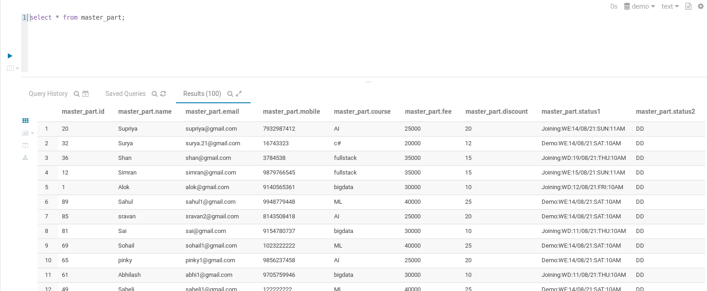

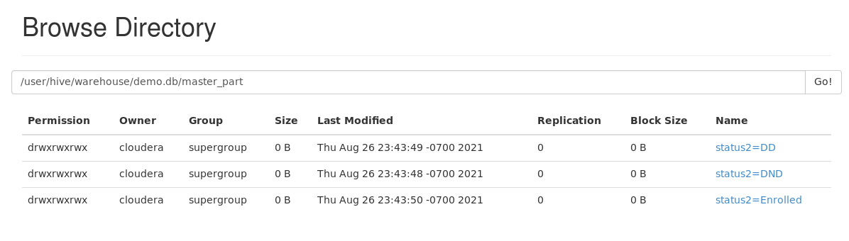

**STATUS2 = DD**

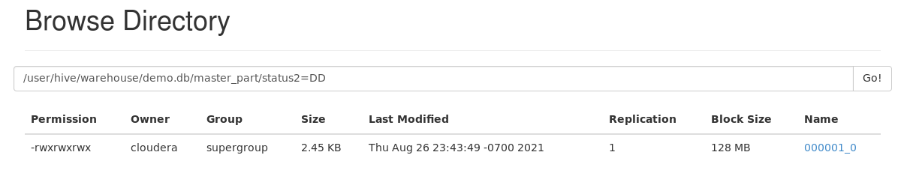

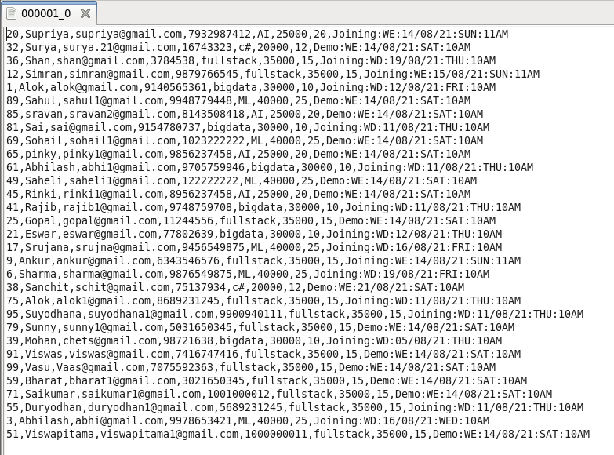

**STATUS2 = DND**

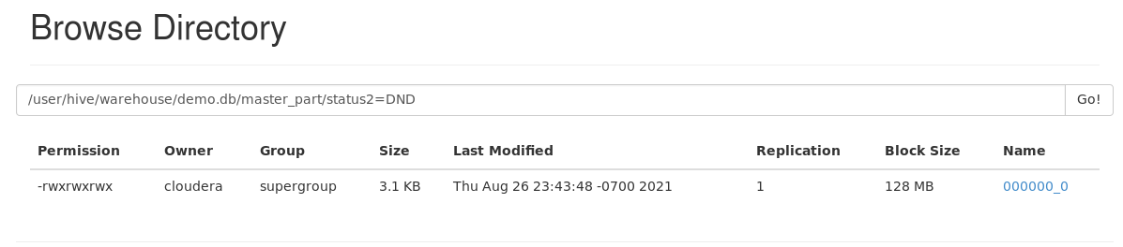

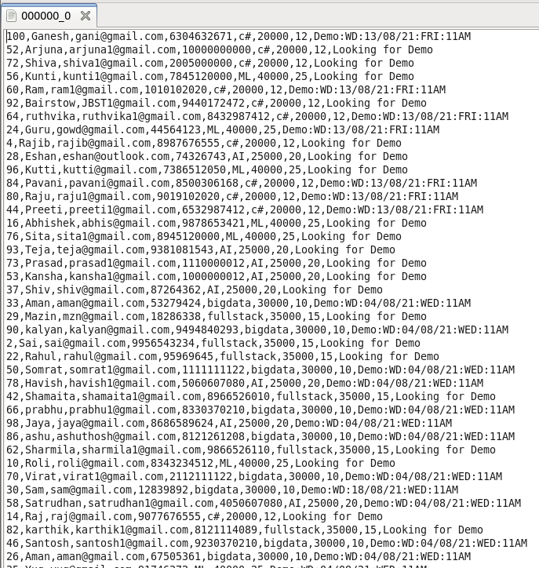

**STATUS2 = ENROLLED**

